Session 4 – Network Operating System Installation
Objectives
- Preparing for Installation
- Windows 2003/8/12 Installation Process
- Choosing Good Passwords
- Windows 2012 Service Pack Considerations

4.1 Preparing for Installation
During Installation, the Setup program will ask for information on how to install and configure Windows 2003/8/12. Prepare for the Windows 2003 operating system installation by collecting hardware information and establishing configuration decisions prior to initiating the installation process. The following checklist provides some guidelines as to the information that needs to be defined prior to initiating the installation process.

4.2 Windows 2003/8/12 Pre-Installation Checklist

Hardware Compatibility: Review all hardware to ensure compatibility with the Windows 22003/8/12 003 operating system. Hardware components include: Motherboard, network adapters, video card, sound card, CD-ROM drives, etc. The Windows 2003/8/12 Hardware Compatibility List (HCL) can be found at:
http://www.microsoft.com/windows2003/server/howtobuy/upgrading/compat/

Disk Space: Ensure the system has sufficient disk space. The minimum disk space recommended for installation of Windows 2003/8/12 is 5 gigabytes (GB).

Disk Partitions: Determine disk-partitioning requirements, keeping in mind the minimum disk space recommendations for installation of the Windows 2003 operating system.

File System: The file system must be configured as NTFS in order to allow configuration of security. A commonly held misconception is that it is easier to recover a system that is running with a FAT partition. This is not true. FAT only makes you less secure, it does not ease recovery.

Installation Method: Determine whether the Windows 2003 operating system will be installed from Setup boot disks, CD-ROM, or over-the-network.
Procedures provided in this document describe installations from boot disks or from CD-ROM.

Service Components: Prior to installation, determine the services that will be required for the installed operating system. For server installations, considerations may include Active Directory, DNS, WINS, or DHCP.

4.3 Windows Server 2003/8/12 Installation Process

Installation Methods
Windows 2003 can be installed as either an upgrade to an existing Windows operating system or as a new operating system installation. To ensure security Windows 2003 should be the only operating system on the computer and be installed on a clean partition. That is, any previous operating system must be wiped clean from all hard disk partitions within the computer prior to installing Windows 2003.
There are three methods available to install the Windows 2003 operating system:
- Setup boot disks – This method is designed to be used with legacy computers which do not support bootable CD-ROM disks. It will not be discussed further
- CD-ROM
- Over-the-network – These are discouraged except in environments where the network can be guaranteed to be non-hostile.

4.3.1 Initiating the Installation from a Bootable CD-ROM
Using a bootable CD-ROM is the simplest and fastest method of installing Windows 2003/8/12. To ensure that the machine is not compromised during setup, however, it is highly recommended that it be disconnected from the network until setup is complete and the most recent service pack is installed.
Start Setup from a bootable CD-ROM as follows:
- Insert the CD-ROM in the drive.
- Restart the computer and wait for Setup to display a dialog box. On many computers you will be required to press any key during the boot process to boot from a CD-ROM.
- Follow the Setup instructions on the screen.
In the remainder of this chapter, we will point out the most secure way of installing the system. This is not intended as a complete walk-through of the setup process.

4.3.2 Configuring Disk Partitions
During the initial text-mode setup of the system, setup will ask where to install Windows 2003. Figure 1 shows the dialog presented. If there are multiple partitions or multiple hard disks they will be identified in the display. The example in Figure 1 below shows a 40 Gigabyte Hard disk that is not partitioned. For security purposes, it is highly recommended that this dialog be used to delete all other operating system partitions from the system. For workstations, we recommend using all space on a disk for the installation partition. For servers, we recommend using about 4 GB of space on one disk for the operating system. The remaining space in the system should be reserved for data files, services, utilities and so on. We highly discourage storage of user data files on the boot partition on servers, while on workstations this is acceptable practice which makes it easier for users to locate their data.
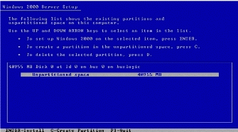
Figure 4.1: Select a disk partition

The next step after creating the partition is to format it. For all systems where security is a requirement all partitions must be NTFS formatted. Only on systems using NTFS can any reasonable security be presumed.

4.3.3 Assign an Administrator account password
The Computer Name and Administrator Password dialog box shown in Figure 2 provides a means of setting the password for the default Administrator account. The specific guidance on how to set a good password is provided in the section 3.3, Choosing Good Passwords It is imperative that a good password is set on the built-in Administrator account during setup.
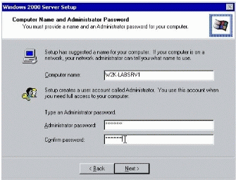
Figure 4.2: Computer Name and Administrator Password Dialog

4.3.4 Choose service components for Windows 2003 Server products
In the Windows 2003 Components dialog box, select the necessary components for the server being installed. This dialog box allows addition or removal of components during installation. The default configuration of Windows 2003 Professional is acceptable, but Windows 2003 Server needs to be modified during installation.
- Several components should not be selected as they decrease the security of the system. These include the Simple TCP/IP Services, and the SNMP protocol.
- For server installations, Indexing Service, Internet Information Service (IIS), and Script Debugger are selected for installation by default in the Windows 2003 Components dialog box. However, most systems do not need these components. On non-web servers IIS and the Script Debugger should be deselected. On systems that do not need file indexing for searching files, the Indexing Service should be deselected, as shown in Figure 3. Note that systems running Microsoft Exchange 2003 will need certain portions of IIS installed. However, security configuration of Exchange 2003 is beyond the scope of this guide. Please refer to the Security Operations Guide for Exchange 2003 Server for more information on Exchange 2003 Server: (http://www.microsoft.com)

Note that due to the prevalence of worms exploiting unsecured systems on most networks, it is highly recommended that system running IIS are installed on an isolated network segment, or with no network cable attached, until Service Pack 3 or higher is installed.
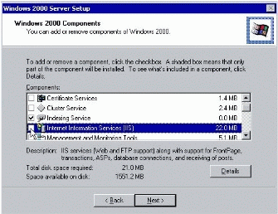
Figure 4.3: Selecting Windows 2003 Components

4.4 Convert a Windows 2003 Server to a Domain Controller
To build a domain controller, you must first install one of the Windows 2003 Server family of products, and then promote the system to a domain controller. This can be done using the DCPromo.exe tool. During promotion, you will be presented with a dialog labeled Permissions (see Figure 4). On this dialog, the radio button for Pre-windows 2003 compatible permissions is selected by default. When this option is selected, the Everyone group becomes a member of the Pre-Windows 2003 Compatible Access group. That latter group, in turn, has read access to all attributes of all objects in Active Directory. This presents a serious potential for security leaks. If you have a system that has already been promoted, you can verify whether this check box was selected by verifying the membership of the Pre-Windows 2003 Compatible Access group. If Everyone is a member of that group, remove it, and then reboot all domain controllers. A reboot is necessary because the access token governing this access is created at boot time.

On new installations, where access by non-Windows 2003 servers and clients is not a requirement, this option should be selected. This is only the first example of an instance where we can tighten the security significantly in the absence of backward compatibility.
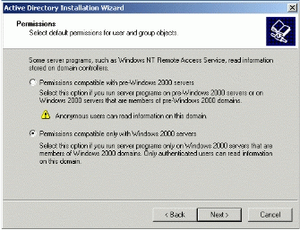
Figure 4.4: Active Directory Permissions Dialog

4.5 Choosing Good Passwords
So much of system security is dependent on choosing good passwords. This topic is covered in detail in this section. In order to understand how to select good passwords on Windows 2003, however, a basic understanding of how the operating system stores passwords is required.

Windows 2003 Password Representations
By default, Windows 2003 will never store a clear-text user password. Rather, passwords are stored using two different password representations, commonly called "hashes." The reason for using two representations is for backward compatibility.

What constitutes a good password?
There are some general guidelines for what constitutes a reasonable password:
- Longer than 7 characters (otherwise the second half of the LMHash is an encryption using the NULL password
- Contains elements from at least three of the following four character sets
  - Uppercase characters
  - Lowercase characters
  - Numbers
  - Non-alpha numeric characters
- Does not contain any part of the users name, username, or any common word
This complexity is enforced via a password filter, and can be optionally required using group policy. Additionally, an administrator can customize the complexity requirements by writing a custom password filter. Such a filter could, for example, enforce that company names are not part of the password, or require additional complexity. For more information on how to write such a filter, refer to section on Password Filters in the Microsoft Windows Software Development Kit, at http://msdn.microsoft.com/library/en-us/security/Security/password_filters.asp.

However, most passwords like these are still easily cracked. There are several steps that can be taken to make a password harder to crack
- Use non-alpha numeric characters other than those from the "upper row." Upper row characters are those you type by holding down SHIFT and typing any number key. Most password crackers know that the upper row characters are the most common method to add entropy to a password and therefore start cracking with those.
- Use ALT characters. ALT characters are those that you type by holding down the ALT key (the FN+ALT keys on a laptop) and typing a three or four digit number on the numeric keypad (the numeric overlay keypad on a laptop). Most password crackers are not capable of testing the vast majority of ALT characters.

